Chapter 7 Lesson 2: Asexual Reproduction
What is asexual reproduction?
- In asexual reproduction, one parent organism produces offspring without meiosis and fertilization.
- Offspring produced by asexual reproduction inherit all of their DNA from one parent. Therefore, they are genetically identical to each other and their parent.
Types Of Asexual Reproduction
- Fission
- Mitotic Cell Division
- Budding
- Animal Regeneration
- Vegetative Regeneration
- Cloning

- Fission
Recall that a prokaryotic cell, such as a bacterial cell, has a simpler cell structure than a eukaryotic cell. A prokaryote’s DNA is not contained in a nucleus. For this reason, mitosis does not occur and cell division in a prokaryote is a simpler process than in a eukaryote.
Cell division in prokaryotes that forms two genetically identical cells is known as fission.
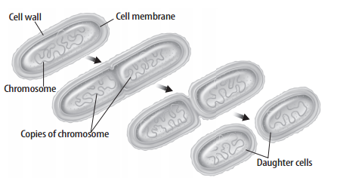
Fission begins when a prokaryote’s DNA is copied, as shown in the figure above. Each copy attaches to the cell membrane. Then the cell begins to grow longer. The two copies of DNA are pulled apart. At the same time, the cell membrane starts to pinch inward along the middle of the cell. Finally the cell splits and forms two new identical offspring. The original cell no longer exists. Fission makes it possible for prokaryotes to divide rapidly.
- Mitotic Cell Division
- Many unicellular eukaryotes, such as amoebas, reproduce by mitotic cell division. In this type of asexual reproduction, an organism forms two offspring through mitosis and cell division.
Example: Amoebas
The nucleus of the cell divides by mitosis. Next, the cytoplasm and its contents divide through cytokinesis. Two new amoebas form.

- Budding
- In budding, a new organism grows by mitosis and cell division on the body of its parent. The bud, or offspring, is genetically identical to its parent. When the bud is large enough, it can break from the parent and live on its own. Hydra is an example of a multicellular organism that reproduces asexually this way. (See below)

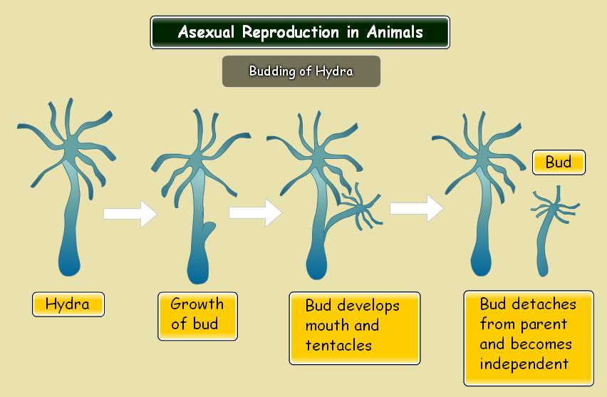

- Animal Regeneration
Regeneration occurs when an offspring grows from a piece of its parent.
- Animals that can reproduce asexually through regeneration include sponges, sea stars, and planarians.
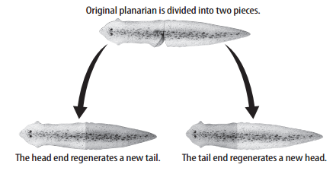

The figure above shows how a planarian reproduces through regeneration. If the planarian is cut into two pieces, each piece of the original planarian becomes a new organism.
* As with all types of asexual reproduction, the offspring are genetically the same as the parent.
5. Vegetative Reproduction
Vegetative reproduction is a form of asexual reproduction in which offspring grow from part of a parent plant.
Examples: -- Strawberries, raspberries, potatoes, and geraniums are types of plants that can reproduce this way.
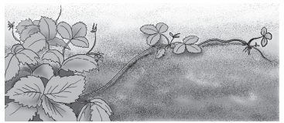
Strawberry Plant – the smaller plants were grown from stolons produced by the parent plant. Each new plant grown from a stolen is genetically identical to the parent plant.

6. Cloning
Cloning is a type of asexual reproduction performed in laboratories that produces identical individuals from a cell or from a cluster of cells taken from a multicellular organism.
Plant Cloning
Some plants can be cloned from just a few cells using a method called a tissue culture. Tissue cultures make it possible for plant growers and scientists to make many copies of a plant with desirable traits (like large flower blooms). The new plants are genetically the same as the parent plant.
Why clone plants? - A plant might be infected with a disease. To clone such a plant, a scientist can use cells from the meristem of the plant. Cells in meristems are disease-free. Therefore, if a plant becomes diseased, it can be cloned using meristem cells.
Animal Cloning
In addition to cloning plants, scientists have been able to clone many animals. All of a clone’s chromosomes come from one parent, the donor of the nucleus. This means that the clone is genetically the same as its parent.
- The first mammal cloned was a sheep named Dolly. The steps to clone Dolly are below
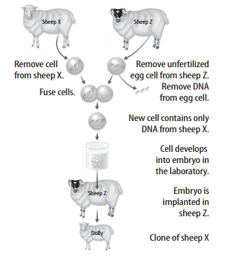
Cloning Issues -- Scientists are working to save some endangered species from extinction by cloning. Some people are concerned about the cost and ethical issues of cloning. Ethical issues include the possibility of human cloning.
Advantages of Asexual Reproduction
- One advantage of asexual reproduction is that an organism can reproduce without a mate.
- Another advantage is that some organisms can quickly produce a large number of offspring.

Disadvantages of Asexual Reproduction
- Asexual reproduction produces offspring that are genetically the same as the parent. This results in little genetic variation within a population.

- Another disadvantage involves genetic changes called mutations. A harmful mutation passed to asexually reproduced offspring could affect the offspring’s ability to survive.

